Catherine Moldoveanu

Computer Science A-level

Windsor College

**Curve Calculator**

**CONTENTS PAGE**

**1.** **ANALYSIS** 1.1 Project Proposal

1.2 Research

1.2.1 Interviews (interview with teacher, ask specific questions)

1.2.2 Direct Observation (write about how using this would improve, for me and the teacher and other students) DONE

1.2.3 Source Documents (pictures of formulas from the books that are annotated and explained) DONE

1.2.4 Internet Survey (also named as internet search, which is looking for source code of programs online that perform the same task as your project, taking screenshots, giving the website and annotating it etc.) DONE

1.2.5 Summary of Research (Talk about the main pieces of information, that I found out in the previous chapters and summarise them)

1.3 Initial Modelling

1.3.1 Initial ER-Diagram

1.3.2 Initial Screen design Ax Navigation

1.3.3 File Layout – Initial

1.3.4 Data Flow Diagram

1.3.5 Object Analysis Diagrams

1.3.6 State Transition Diagrams

1.3.7 Major Variables and Calculations

1.4 Final SMART Objectives

**2.** **DOCUMENTED DESIGN**

2.1 Overall System Design

2.2 Data Dictionary

2.3 Validation

2.4 Files

2.5 Algorithms

2.6 Data Structures

2.7 User Interface

**3.** **TECHNICAL SOLUTION** 3.1 Program Code

**4.** **TESTING** 4.1 Test Plan

4.2 Test Evidence

**5.** **EVALUATION**

5.1 Evaluation of objectives

5.2 Evaluation of whole solution compared with the start

5.3 User Feedback

5.4 Analysis of user feedback

5.5 Extensions and Improvements

1. **ANALYSIS**
   1. **Project Proposal**

1.1.1 The User

My client’s name is Kate Cubitt. Her relation to me is that she is my teacher. Since she is my teacher, I should have access to her several times a week on school days.

1.1.2 The Area to be Computerized

The area to be computerized are math’s formulas, around drawing curves and polynomials, integrating and differentiating them. The process of using and calculating data in different formulas will be done by the computer, while the user picks the formula to be used and enters the relevant data.

1.1.3 Problem Statement

My teacher has the problem of physically writing out and implementing the formula and drawing graphs by herself which takes a long time when testing and checking tests and doing questions herself. By computerizing these formulas, the process of checking the answers will become much quicker. These speeds up the overall process and makes answering and checking questions easier.

1.1.4 Possible Project Objectives

1. A clear and simple design for the calculator which makes it easy and simple for the user to use, with clear and simple buttons.

2. The user can write out the formula in a string and the calculator can take that string and use it to integrate, differentiate and create curves and graphs

3. The ability to display graphs and save them in a text file, as well as being able to access and display them from the calculator again.

4. The ability to automatically display the curve’s maximum and minimum.

5. To automatically display where the line crosses the x and y axis automatically.

6. The ability to pick a point on the curve and for the co-ordinates to be displayed.

7. The ability to present up to 5 curves on a graph.

7. For the graph to automatically scale based on the formula written in the calculator.

9. For the calculator to store the previous answer until a new answer is created and stored in its place as well as being able to clear the screen.

10. For there to be no limit to the power of x to be entered and given.

* 1. **Research**

1.2.1 Interview

Date taken: 30/03/2021

1. A: What area needs to be computerized?

Kate: To be able to type in an equation and I would like to be able to get the computer to differentiate it and integrate it. I would like the computer to show the graph of that equation. I would like it to be able to use the trapezium rule that it will be able to integrate any equation that cannot be integrated algebraically. I would also like it to be able to do the cobb web method and Newton Rason method for solving equations numerically, and I would like it to graph these equations.

1. A: How would you like it to benefit you, if this area was computerized?

Kate: It would benefit my interest, especially the cobb web method and the Newton Rason method, because I love math and the beauty of curves.

A: What sorts of formulas would you like to be on the calculator?

Kate: Formulas for integration, differentiation, and polynomials as well as ones with asymptotes.

4. A: How complex would you like the design of the calculator to be?

Kate: Very clear, large size, easy to use. I want everything on one screen.

1. A: Would you like the option to display graphs as well?

Kate: Yes

6. A: Are there other users who will use your system?

Kate: Potentially other students if they are interested.

1. A: What do you plan on using my program on?

Kate: Math questions done in my spare time.

1. A: How confident are you with using technology?

Kate: Reasonably well.

1. A: How are you struggling with the current system you have?

Kate: I’m not struggling because I do not have one, but the problem is that I need one.

1. A: Are there any benefits of your current system that you would like to keep?

Kate: N/A

1. A: Approximately how many formulas in total would you like the calculator to hold?

Kate: As many as is necessary in order for it to do what it needs to do.

1. A: Would you like the previous answer calculated to be stored and able to be presented on the calculator? And why?

Kate: I would like to save curves and formulae of the curves I have enjoyed looking at on a text file so that I can bring it up and look at it again.

1. A: Would you like the text file to be accessible from the calculator?

Kate: Absolutely, because I would like to load and use the curves that I have used before.

1. A: How many curves would you like to display on the same graph?

Kate: I would like to display up to 5 curves on the same graph.

1. What kind of scale would you like on the graphs?

Kate: I would like the graphs to automatically scale depending on the formulae and information I put in.

1. Is there a limit to the number of polynomials would you like to use?

Kate: I would like to type in any power of x I want.

1. How would you like to input the information?

Kate: I would like to type it all in as one string and for the calculator to use that and apply it, as well as buttons for integration and differentiation.

1. Would you like to clear the previous information? Or to temporarily store the answer?

Kate: I would like to clear the screen, but to temporarily store the previous answer until a new answer is created.

1. Would you like to be able to pick a point and display the co-ordinates on a graph?

Kate: Yes.

1. Would you like it to automatically display maximums and minimums as well as points where the x and y axis cross automatically?

Kate: Yes

Note (source code): Go through maths textbook and take picture of the formulas and annotate them. Take screenshots of different curves. Find the trapezium rule questions, and learn them.

1.2.2 Direct Observation

Through observation I have learned, that having a curve calculator is beneficial for several people: myself, my classmates and my teacher. In my math class we have several topics that rely on the use of graphs especially graphs with polynomials which can be considerably difficult to figure out.

My math teacher could quickly check in advance that the formula is used is going to give the type of curve that he wants, make sure that there are no errors and that the question itself is not too hard for the students to solve. They could also be able to fall back on previous formulas used and stored in case, they need more examples, or maybe a specific one. The curve calculator would be able to pick favorite graphs of theirs to use for examples that they already stored previously, without having to waste time to think up an entirely new one or allow them to reuse a very important example. The calculator would also be able to correct any silly mistakes made, making sure that the work does is flawless.

The students in my class including myself have a hard time writing out each step which sometimes is painstakingly long to do. Even with the questions where the process needs to be written out in steps, we have no concrete way of checking whether the steps or the result we have garnered is correct. The results and values used in the calculator can be used to check whether the answers gained in one of the steps is correct, allowing the student to continue with other steps with confidence. Without the calculator students will rely heavily on the teacher, which only adds additional stress onto the professor themselves. By having a curve calculator at hand, we could take pressure off our professor, by checking for ourselves the answers and steps, to see whether we were wrong. Students can also save very difficult graphs for themselves, for later when they have more time, without having to worry about writing it out somewhere else and losing it.

To summarize, by having a curve calculator our lesson improves due to the teacher being able to more efficiently and quickly teach our lesson, as well as the students having to rely lesson on the teacher and be more independent ourselves. This will result in better grades, better quality lessons and more confidence of both the teacher and their students.

1.2.3 Source Documents

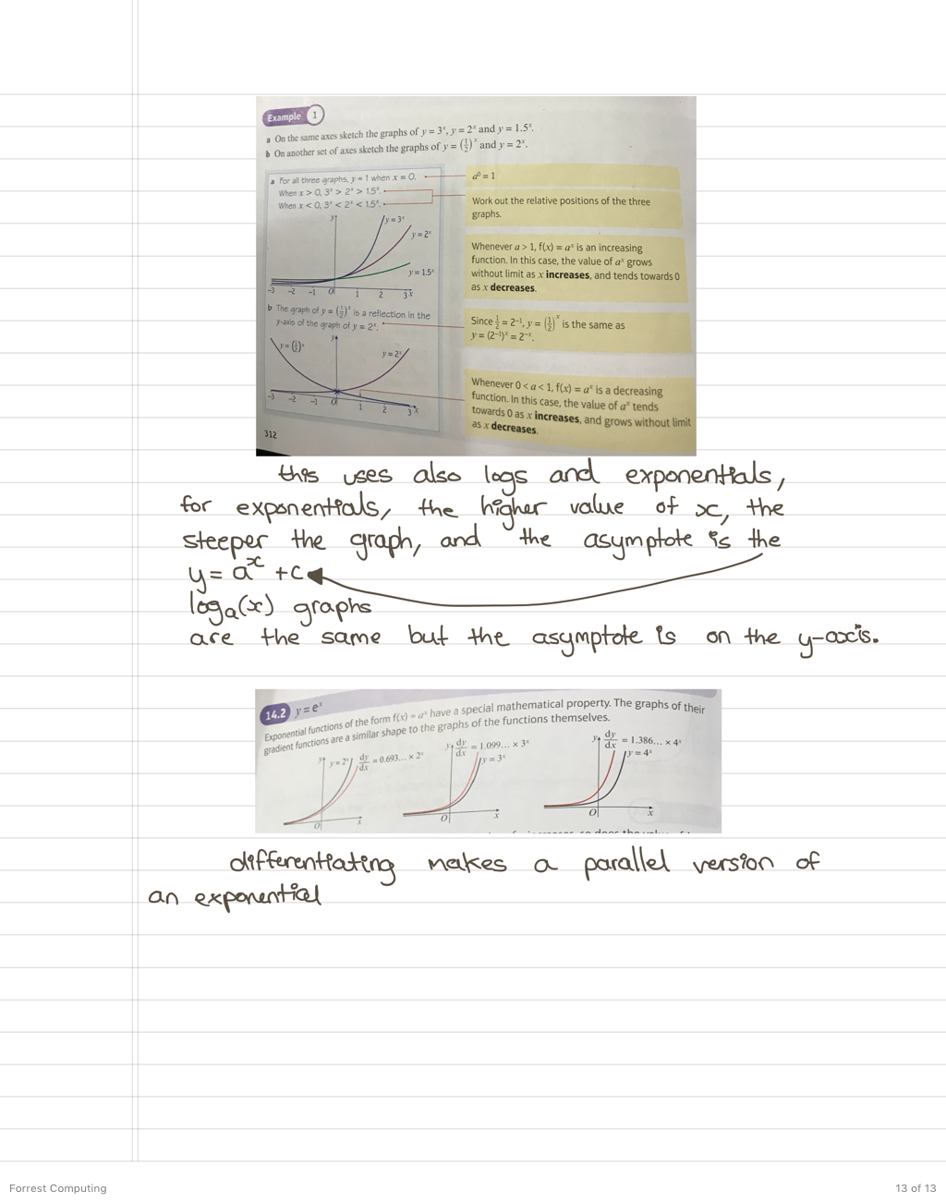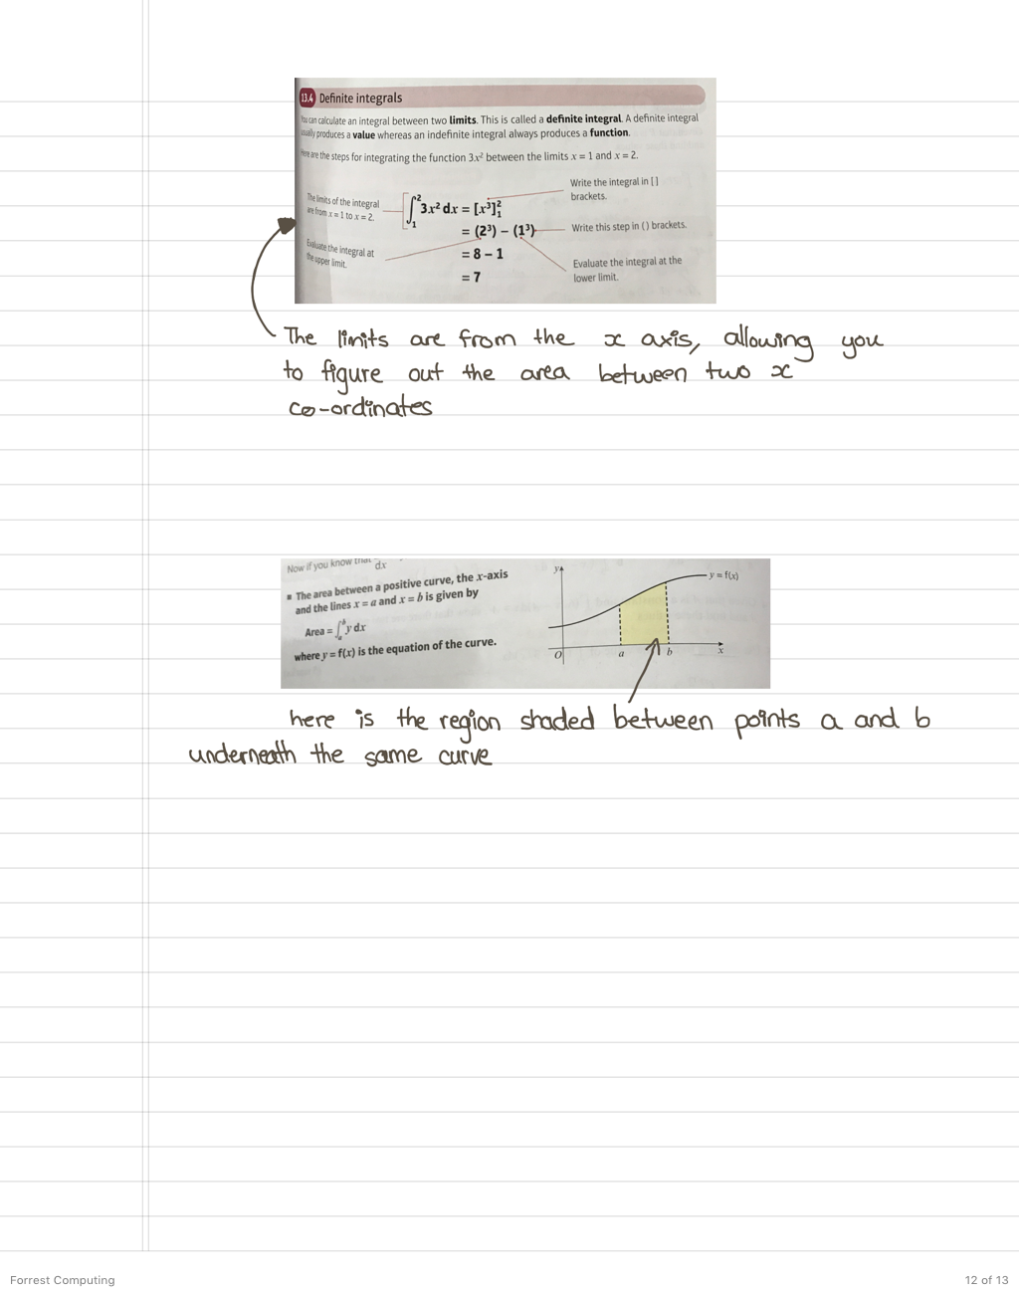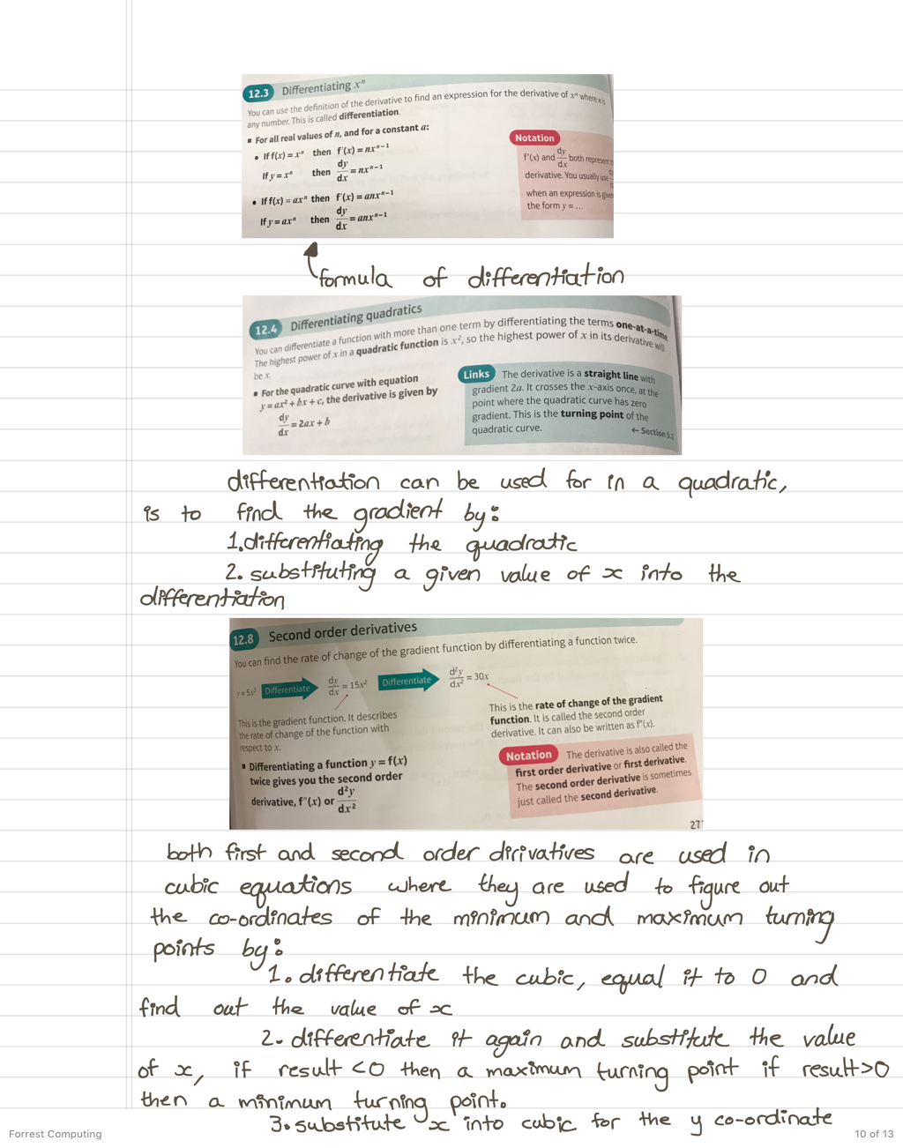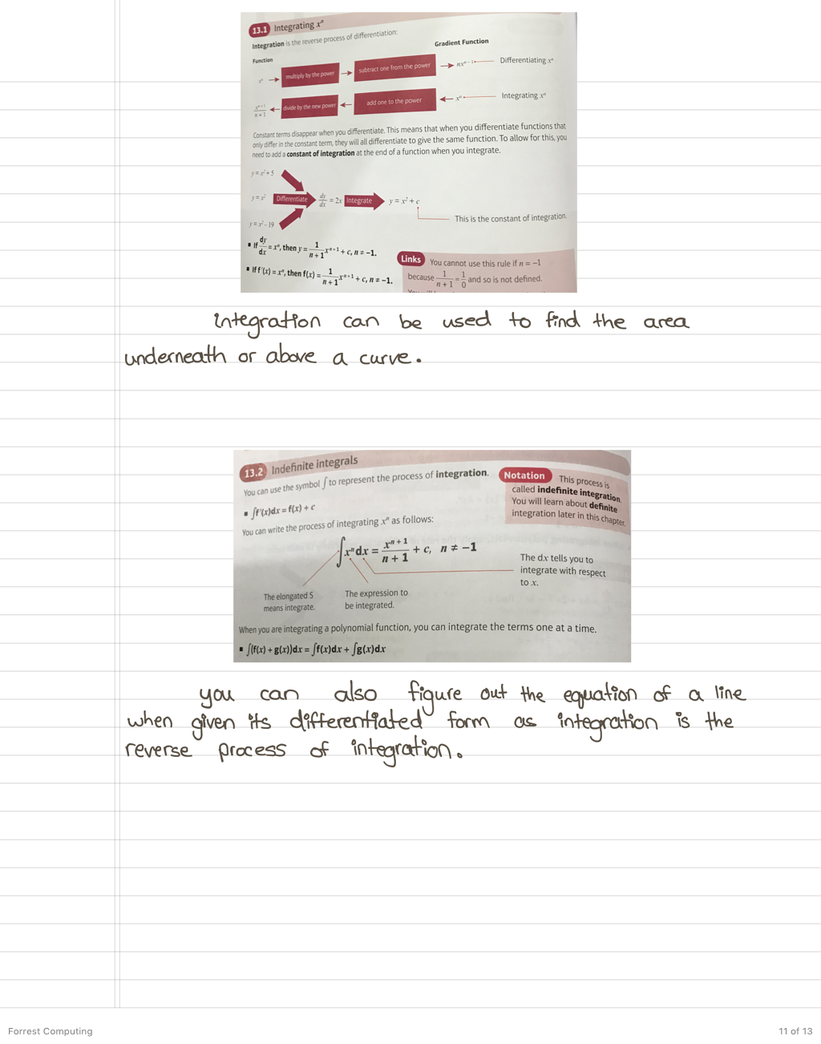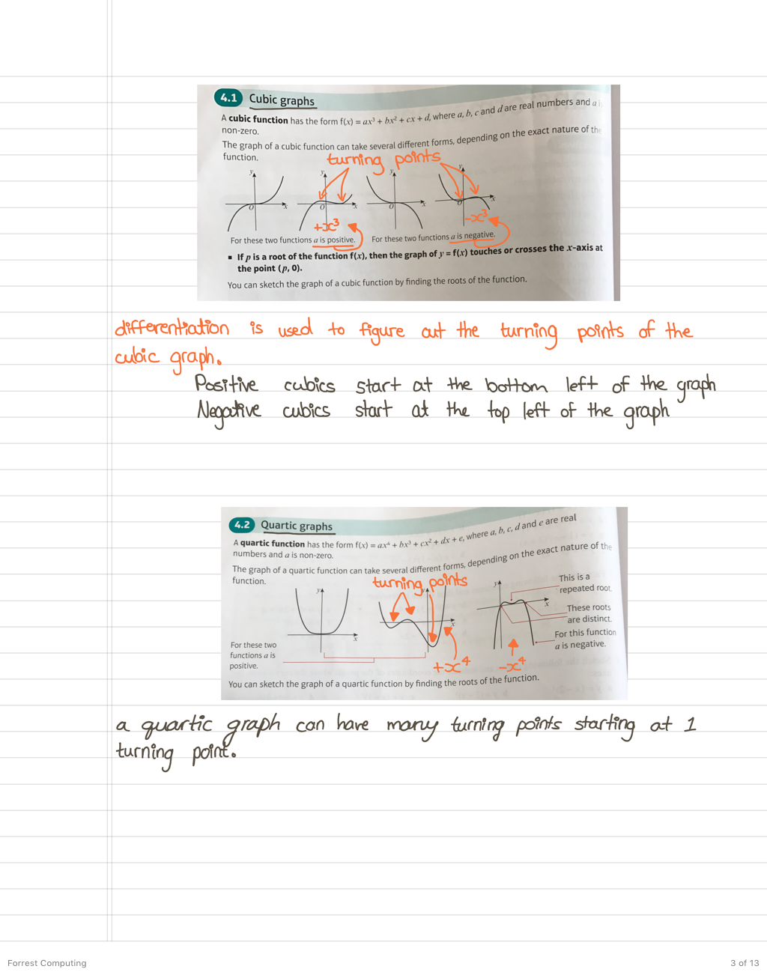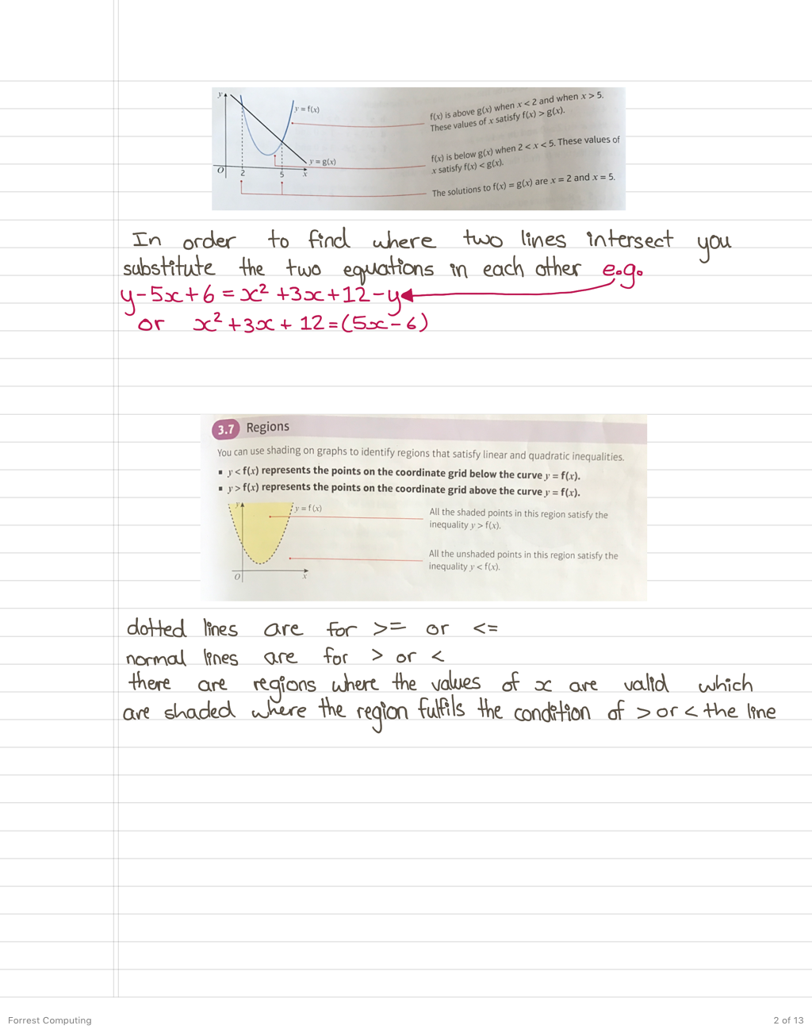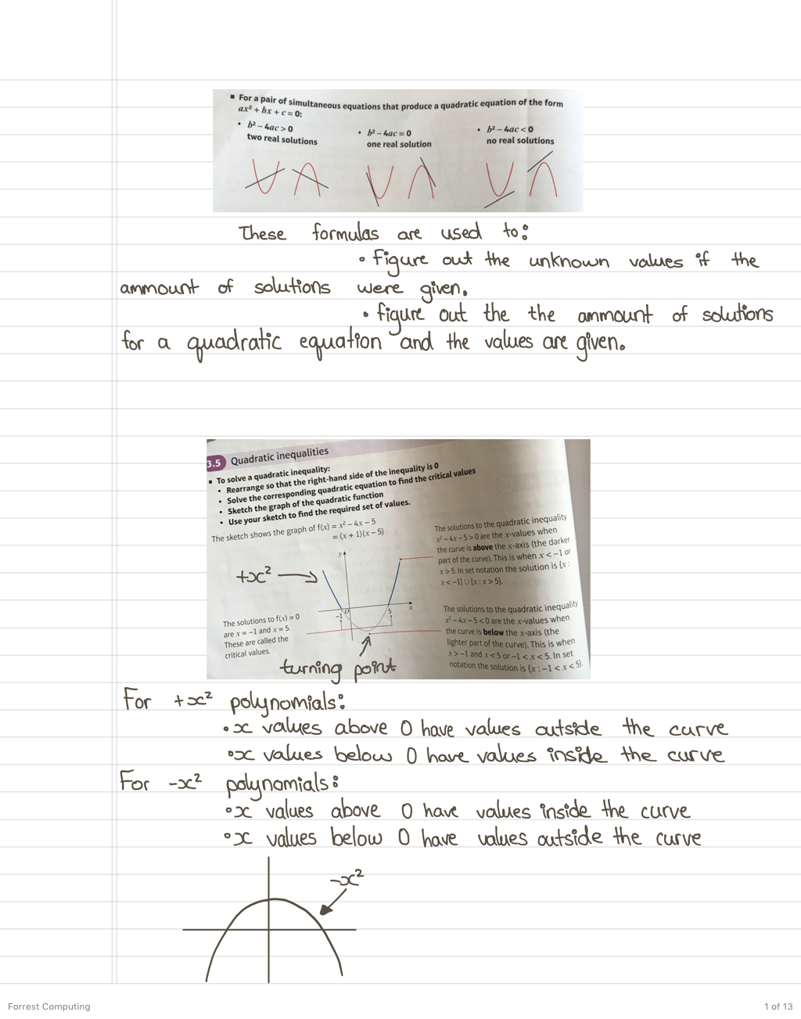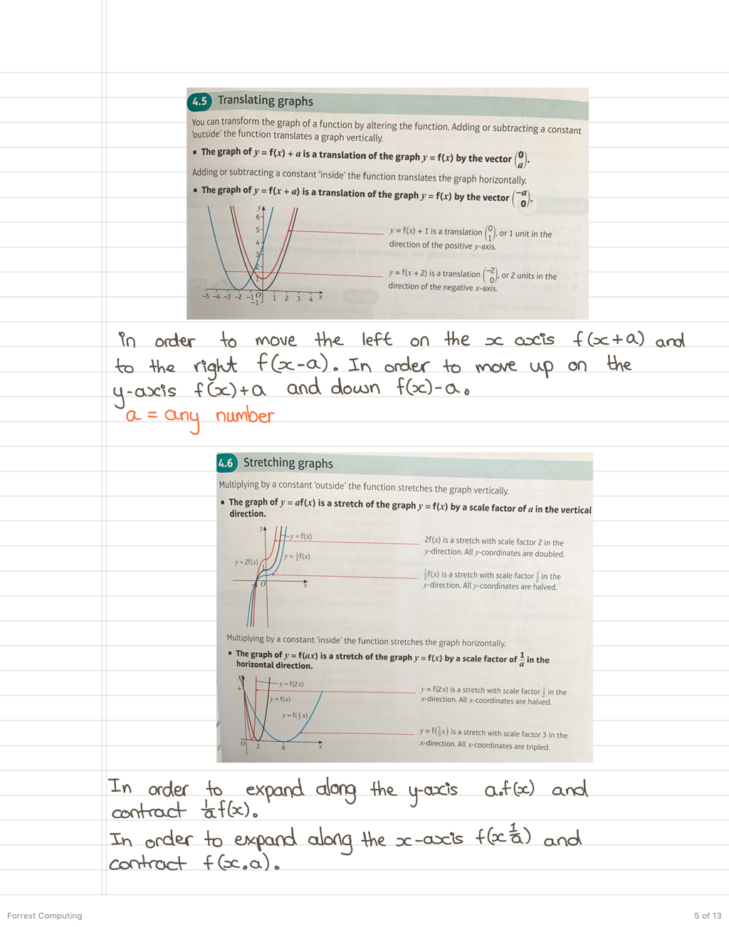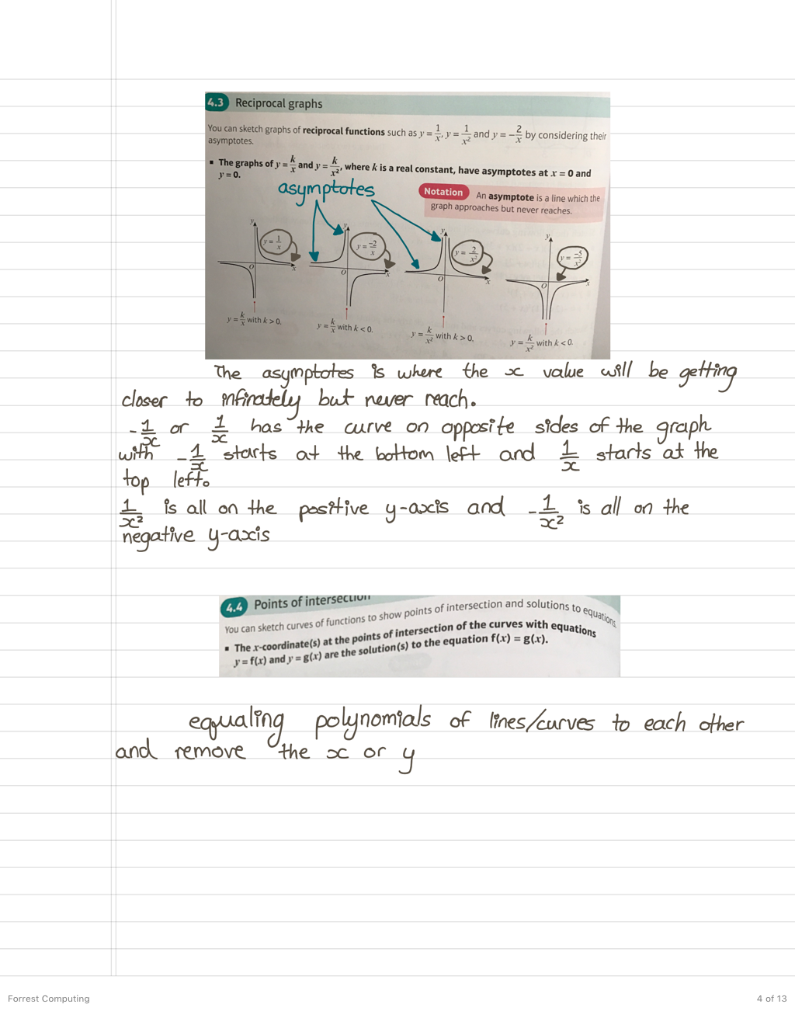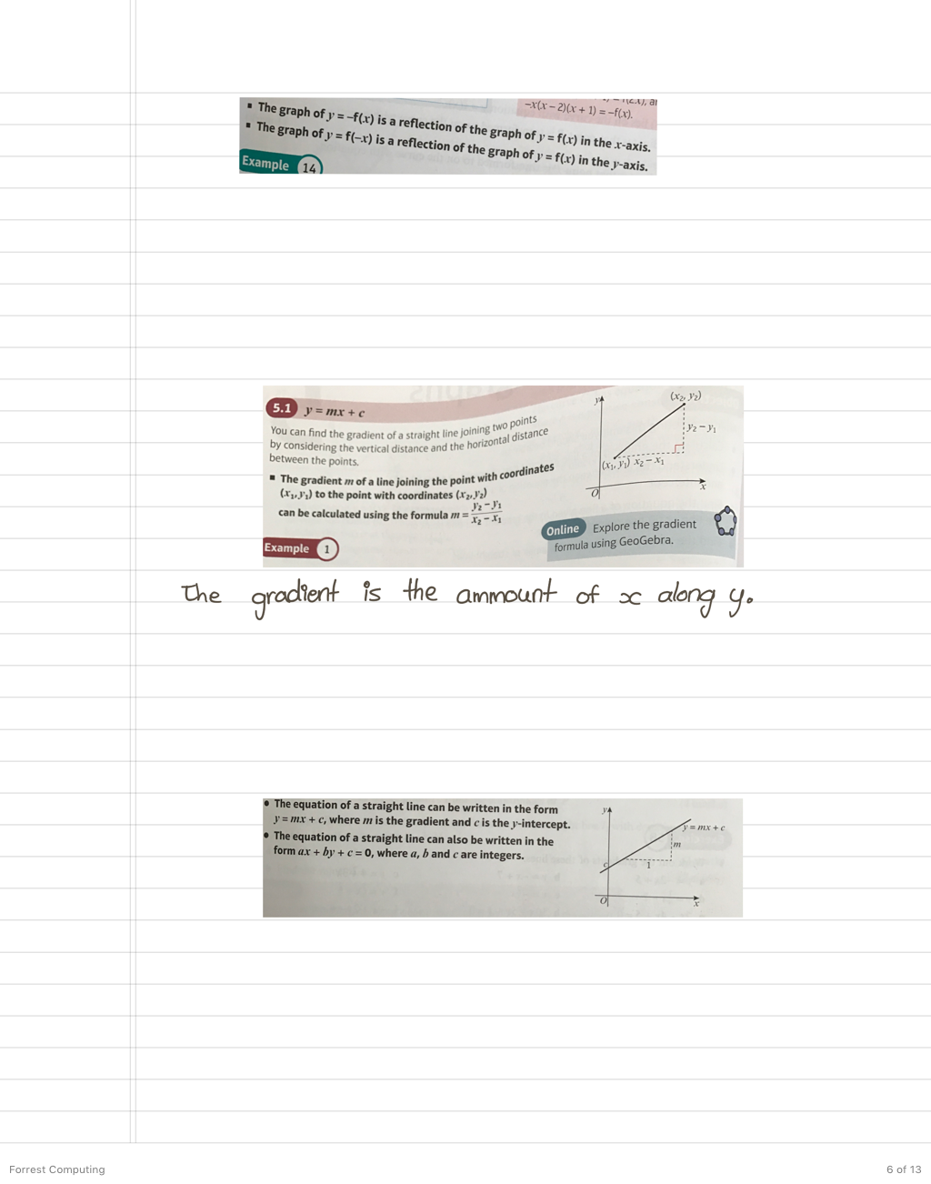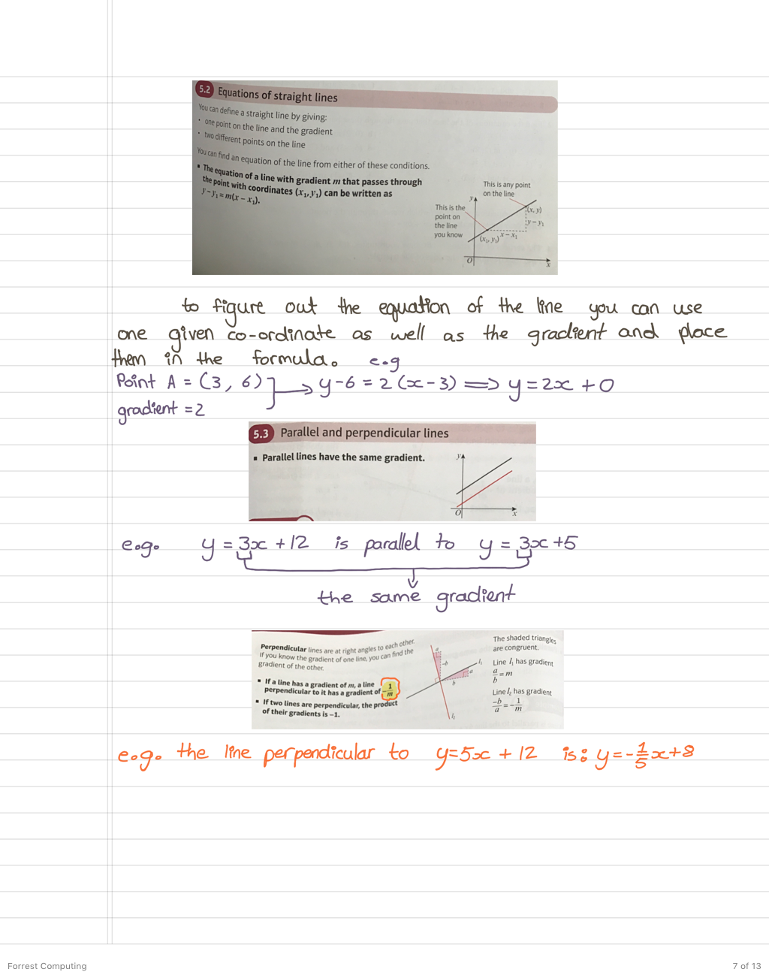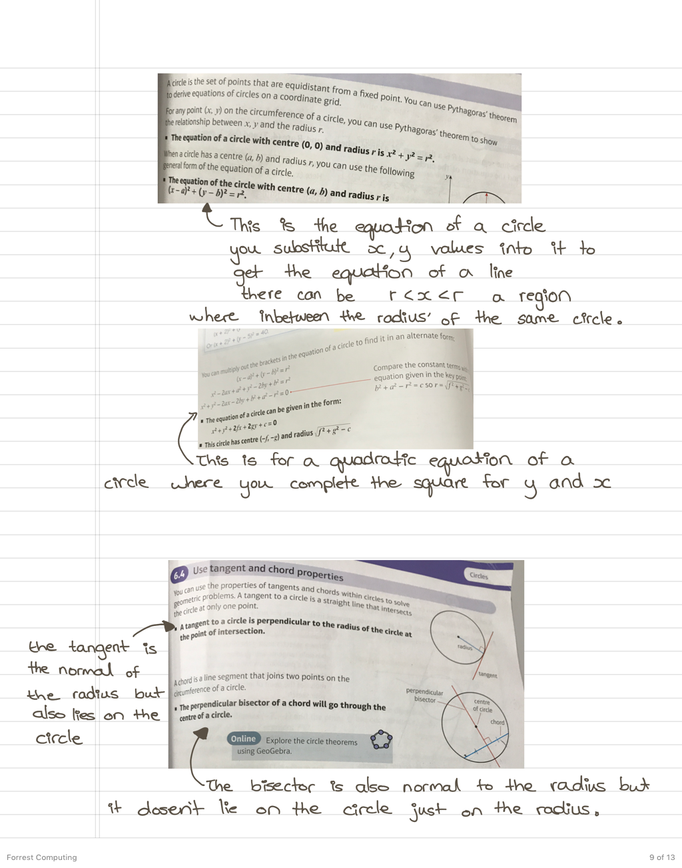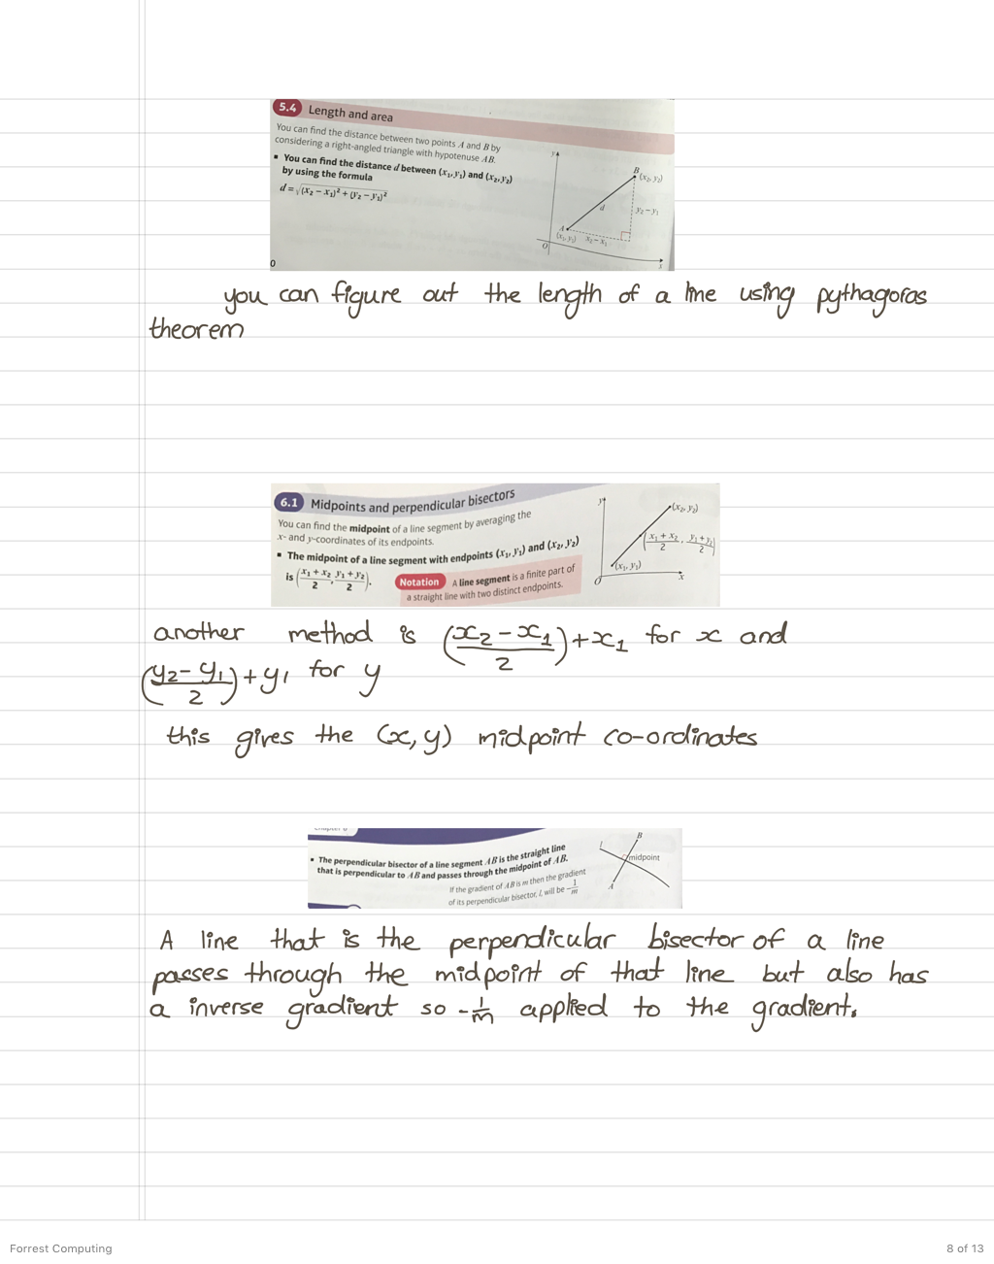

1.2.4 Internet Survey

Code about plotting graphs:

# importing the required module

import matplotlib.pyplot as plt

Here the the functions of the library are imported.

# x axis values

x = [1,2,3]

# corresponding y axis values

y = [2,4,1]

# plotting the points

plt.plot(x, y)

The points of the co-ordinates are defined in a list and plotted using a function.

# naming the x axis

plt.xlabel('x - axis')

# naming the y axis

plt.ylabel('y - axis')

The axes are created and labled.

# giving a title to my graph

plt.title('My first graph!')

Title is created.

# function to show the plot

plt.show()

The function for displaying all of the code on a screen.

This code creates a line.

import matplotlib.pyplot as plt

# line 1 points

x1 = [1,2,3]

y1 = [2,4,1]

# plotting the line 1 points

plt.plot(x1, y1, label = "line 1")

The co-ordinates for the first line being defined with in a list and then being plotted and labelled with the function .plot()

# line 2 points

x2 = [1,2,3]

y2 = [4,1,3]

# plotting the line 2 points

plt.plot(x2, y2, label = "line 2")

The same thing goes for the second line.

# naming the x axis

plt.xlabel('x - axis')

# naming the y axis

plt.ylabel('y - axis')

# giving a title to my graph

plt.title('Two lines on same graph!')

Labels and gives a title to the graph using the function plt.anyName(‘’)

# show a legend on the plot

plt.legend()

This is used for the identification of two lines, usually called a key in maths.

# function to show the plot

plt.show()

import matplotlib.pyplot as plt

# x axis values

x = [1,2,3,4,5,6]

# corresponding y axis values

y = [2,4,1,5,2,6]

The points of x and y are defined

# plotting the points

plt.plot(x, y, color='green', linestyle='dashed', linewidth = 3,

marker='o', markerfacecolor='blue', markersize=12)

The points are plotted to in a color and style with all sorts of different things added to the line to make it look more appealing, making it dotted and such.

# setting x and y axis range

plt.ylim(1,8)

plt.xlim(1,8)

Here the limits of the range of the graph lines are stated.

# naming the x axis

plt.xlabel('x - axis')

# naming the y axis

plt.ylabel('y - axis')

# giving a title to my graph

plt.title('Some cool customizations!')

The title and labels are made

# function to show the plot

plt.show()

import matplotlib.pyplot as plt

# x-coordinates of left sides of bars

left = [1, 2, 3, 4, 5]

# heights of bars

height = [10, 24, 36, 40, 5]

The x and y co-ordinates are defined

# labels for bars

tick_label = ['one', 'two', 'three', 'four', 'five']

The bars are all named

# plotting a bar chart

plt.bar(left, height, tick_label = tick_label,

width = 0.8, color = ['red', 'green'])

The bar is plotted, the width is set and the bars get a color blue or green.

# naming the x-axis

plt.xlabel('x - axis')

# naming the y-axis

plt.ylabel('y - axis')

# plot title

plt.title('My bar chart!')

The x and y axis are labeled and the title is set.

# function to show the plot

plt.show()

import matplotlib.pyplot as plt

# x-axis values

x = [1,2,3,4,5,6,7,8,9,10]

# y-axis values

y = [2,4,5,7,6,8,9,11,12,12]

The x and y vales are defined

# plotting points as a scatter plot

plt.scatter(x, y, label= "stars", color= "green",

marker= "*", s=30)

The points are plotted using details for the marker

# x-axis label

plt.xlabel('x - axis')

# frequency label

plt.ylabel('y - axis')

# plot title

plt.title('My scatter plot!')

# showing legend

plt.legend()

Here is the code for a label, or key to identify them.

# function to show the plot

plt.show()

# importing the required modules

import matplotlib.pyplot as plt

import numpy as np

Two functions are imported this time, numpy for the math functions and a specific matplotlib function for plotting a graph.

# setting the x - coordinates

x = np.arange(0, 2*(np.pi), 0.1)

# setting the corresponding y - coordinates

y = np.sin(x)

For the x axis, the pi function is used and for the y axis the sin of the x values are used, imported from numpy for this program.

# potting the points

plt.plot(x, y)

The points are plotted.

# function to show the plot

plt.show()

The program is displayed on a screen.

This code comes from the website:

<https://www.geeksforgeeks.org/graph-plotting-in-python-set-1/>

Code about integration:

|  |
| --- |
|  |
|  |  |  |
|  |  | scvalue.set(x)  screen.update() |
|  |  |  |
|  |  | elif text == "LOG": |
|  |  |  |
|  |  | value = int(scvalue.get()) |
|  |  |  |
|  |  | x=math.log(value,10) |
|  |  | scvalue.set(x) |
|  |  |  |
|  |  | screen.update() |
|  |  | This is the code that is run if the user picks log, and the functions  are used so that the x value is used accordingly. The screen is  updated accordingly with the new values |
|  |  | elif text == "EXP": |
|  |  |  |
|  |  | value = int(scvalue.get()) |
|  |  |  |
|  |  | x=math.exp(value) |
|  |  | scvalue.set(x) |
|  |  |  |
|  |  | screen.update() |
|  |  | This text is used if the person enter exp for exponential,  using functions for the x values accordingly. The screen is then  set with the updated version. |
|  |  | elif text == "C": |
|  |  | scvalue.set("")  This code is run if the user enters c which mean everything is cleared. |
|  | @@ -122,6 +140,10 @@ def click(event): | |
|  |  | b.pack(side=LEFT,padx=18,pady=2) |
|  |  | b.bind("<Button-1>",click) |
|  |  |  |
|  |  | b=Button(f,text="EXP",padx=5,pady=2,font='lucida 35 bold') |
|  |  | b.pack(side=LEFT,padx=18,pady=2) |
|  |  | b.bind("<Button-1>",click) |
|  |  | Here a button is being created for an exponential, and placed. |
|  |  | f.pack() |
|  |  |  |
|  |  | f=Frame(root, bg="grey") |
|  | @@ -141,6 +163,10 @@ def click(event): | |
|  |  | b.pack(side=LEFT,padx=18,pady=2) |
|  |  | b.bind("<Button-1>",click) |
|  |  |  |
|  |  | b=Button(f,text="LOG",padx=5,pady=2,font='lucida 35 bold') |
|  |  | b.pack(side=LEFT,padx=18,pady=2) |
|  |  | b.bind("<Button-1>",click)  Here a button is created for logs. |
|  |  |  |
|  |  | f.pack() |

This code comes from:

<https://github.com/Satyajit99p/GUI-integration-and-differentiation-calculator/commit/78fbd8a65b6e2b37fd4e0bc3047f389f2a2e9d1a>

This code implements a cure in the graph using the sine value:

|  |
| --- |
|  |
|  | import random  import math |
|  | from tkinter import Tk, Canvas, PhotoImage, mainloop  Here libraries are imported, some as a whole, some with specific functions. |
|  |  |
|  | width = 1000 |
|  | height = 600 |
|  | window = Tk() |
|  | canvas = Canvas(window, width=width, height=height, bg="#000000")  The height and width of the canvas are set along with a colour with the TKinter function. |
|  | canvas.pack() |
|  | img = PhotoImage(width=width, height=height) |
|  | canvas.create_image((width//2, height//2), image=img, state="normal")  The image from the same directory is implemented with is height and width set inside the canvas. |
|  |  |
|  | def center_and_invert(y, height): |
|  | return int(height/2 - y)  A function the scaling of the height of the graph is made |
|  |  |
|  | def f(x): |
|  | num_cycles = 4 |
|  | amplitude = 200 |
|  | return amplitude * math.sin(2 * math.pi * (num_cycles / width) * x)  This function makes the actual curve, since the sine value is regarded as a wave hence a curve, the number of cycles and its amplitude (the width) is set. The return value is what the y value is in relation to the x value that is entered. Functions are used from the imports. |
|  |  |
|  | def graph(f, x_range, height): |
|  | for x in x_range: |
|  | y = center_and_invert(f(x), height) |
|  | img.put("#ffffff", (x, y))  This function implements the f() function made and makes the inverted value for the other side of the curve and the values are plotted into an image. The for loop is used for all of the range of values in x to get all pf the co-ordinates. |
|  |  |
|  | graph(f, range(width), height) |
|  | mainloop()  The graph function is called with the values put in and the main loop function from TKinter is used. |

This code is from:

<https://gist.github.com/calebmadrigal/81f3b9de14f54ac355f7>

1.2.5 Summary of Research

For my research I have interviewed the user that will make use of my program and that I am basing it around, I have also observed the situations in which it is used by other people and have noticed what they could benefit from based on this program. I have looked at the math textbook provided that contains the formulas and information that the curve calculator needs to implement to help others. I have also researched online the code that others use and implement for making graphs, curves and implementing formulas of their own.

For the survey I asked my teacher what kind of curve calculator she wanted and what sort of added uses she might want to make it easier for her to use this calculator, as well as what sorts of formulas she wanted the calculator to use, and the results to display. The main idea of what she wanted is for the calculator to display any sort of line, from any polynomial, fraction, exponential, and log. The formulas she wanted me to input would be ones that would be needed in order to implement these types of graphs and display intersection points and turning points as well as any point that is selected on the line/curve.

From the observation I concluded that both the teacher and the students could benefit from having the calculator. The teacher could save and easily access good examples of the of a curve/line and display it easily with whatever points is needed to show, e.g. Intersection points. The students could use this to easily check the answers they have by seeing how the graph is supposed to look like or whatever points the need from their answers.

From the book, I was able to find various useful information and formulas for what I could use in the python program. The formula of integration that is used to find the area underneath curves. Differentiation that finds the gradient of tangents and the turning points for cubic graphs. Exponential and logs that have asymptotes and increase/decrease infinitely. Completing a square that figures out the turning point of a curve. Formulas of lines quadratics, and circles. This information is going to be used to implement in code.

From online research, I looked at the various modules that people use to implement graphs, curves and lines. The modules that I have found that they imported were: TKinter, random, math, numpy and matplotlib. In all of the program functions were used or defined. Lists were used for holding points, .plot() functions were used for plotting lines, a trig value such as sine was used for curves, and more details such as dotted lines or random points were implemented for all sorts of different graphs. I found the usability of matplotlib was quite useful in implementing details in the graphs that made everything look better, like dotted lines, or the neat graphs.

To summarize, from my research I have observed what needed to improve from my observation. The interview helped me to figure out the types of features and formulas I need to use in my program to benefit the user of the calculator. Through looking through the source documents in my math book I have the information and formulas I now need to implement in my code. Lastly, in my internet survey I have looked how others have implemented their graphs with lines and curves, and I know now what I can use for myself to implement the information I have into code.

* 1. **Initial Modelling**

I will have to include the following formulas: integration, differentiation, completing the square, the equation of a line, the equation of a circle, the discriminant formula.

Integration = (number ** (n + 1))/(n + 1)

Differentiation = n * (number ** (n – 1)

Completing the square = a(x – (b/2)) – ((b/2) ** 2) + c

Equation of a line = y = mx + ((m * -x) -y)

Equation of a circle = ((a – x) ** 2) + ((b – y) ** 2) = r **2

Discriminant formula = (b ** 2) – (4 * a * c) = 0

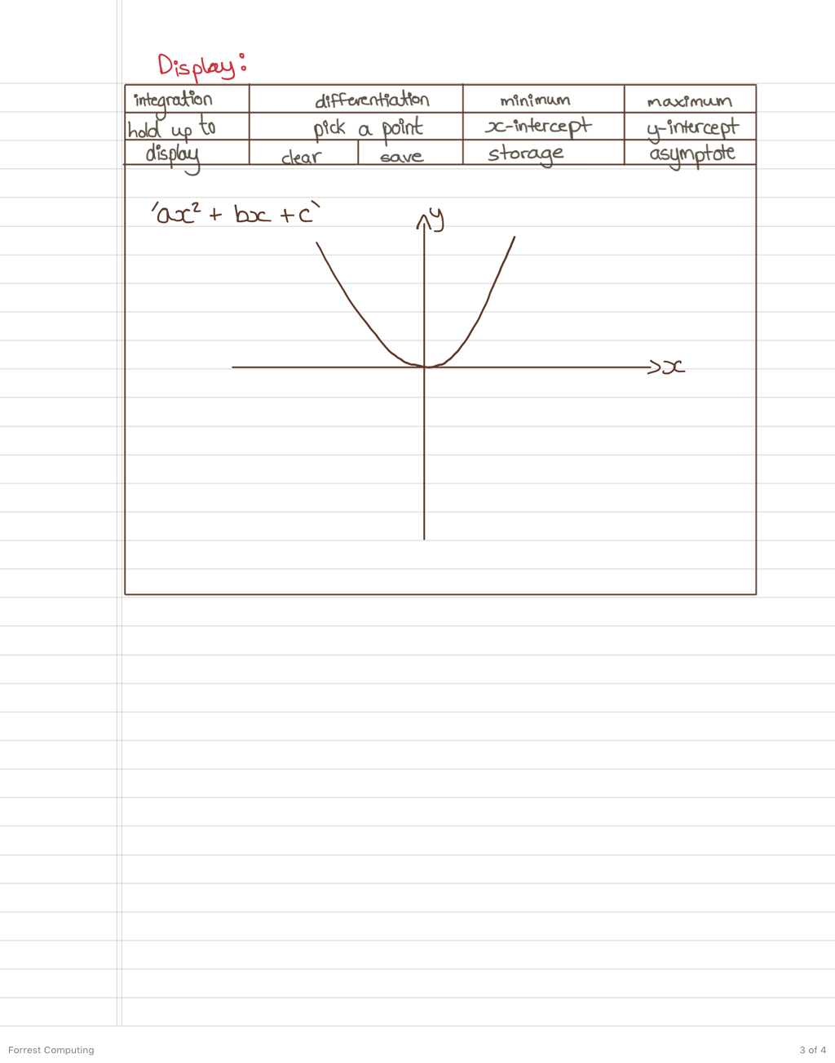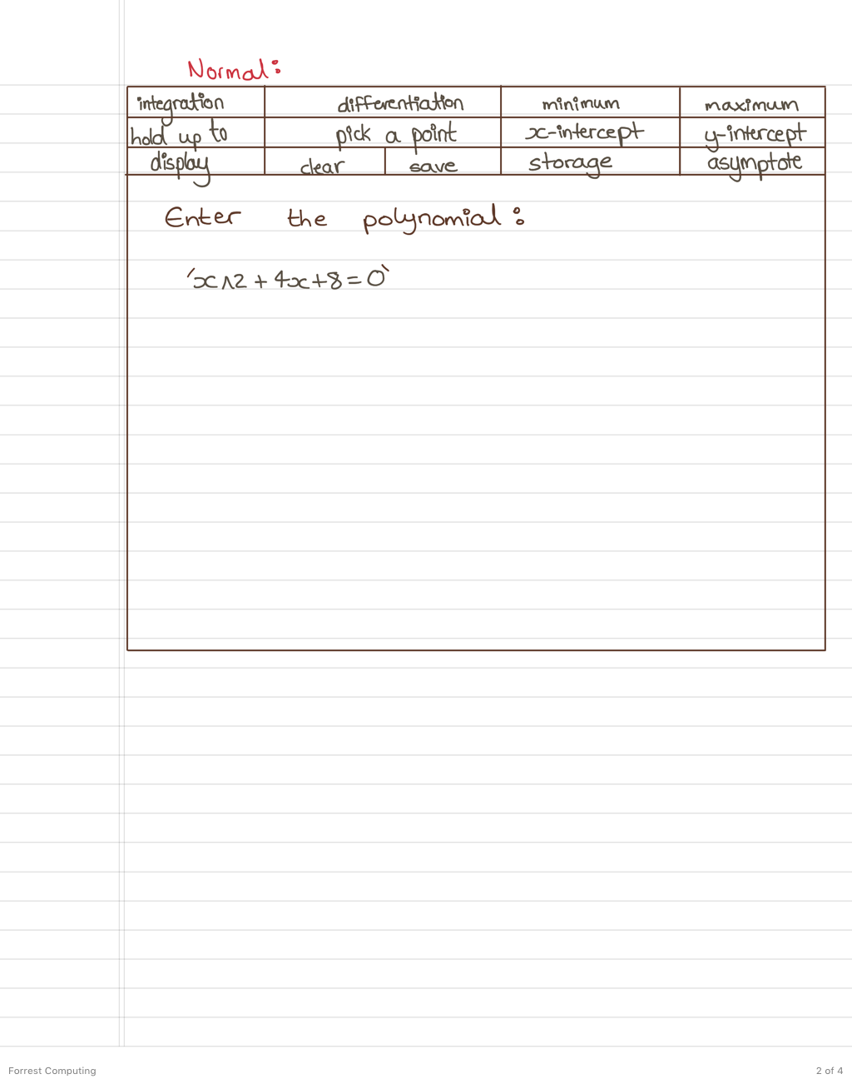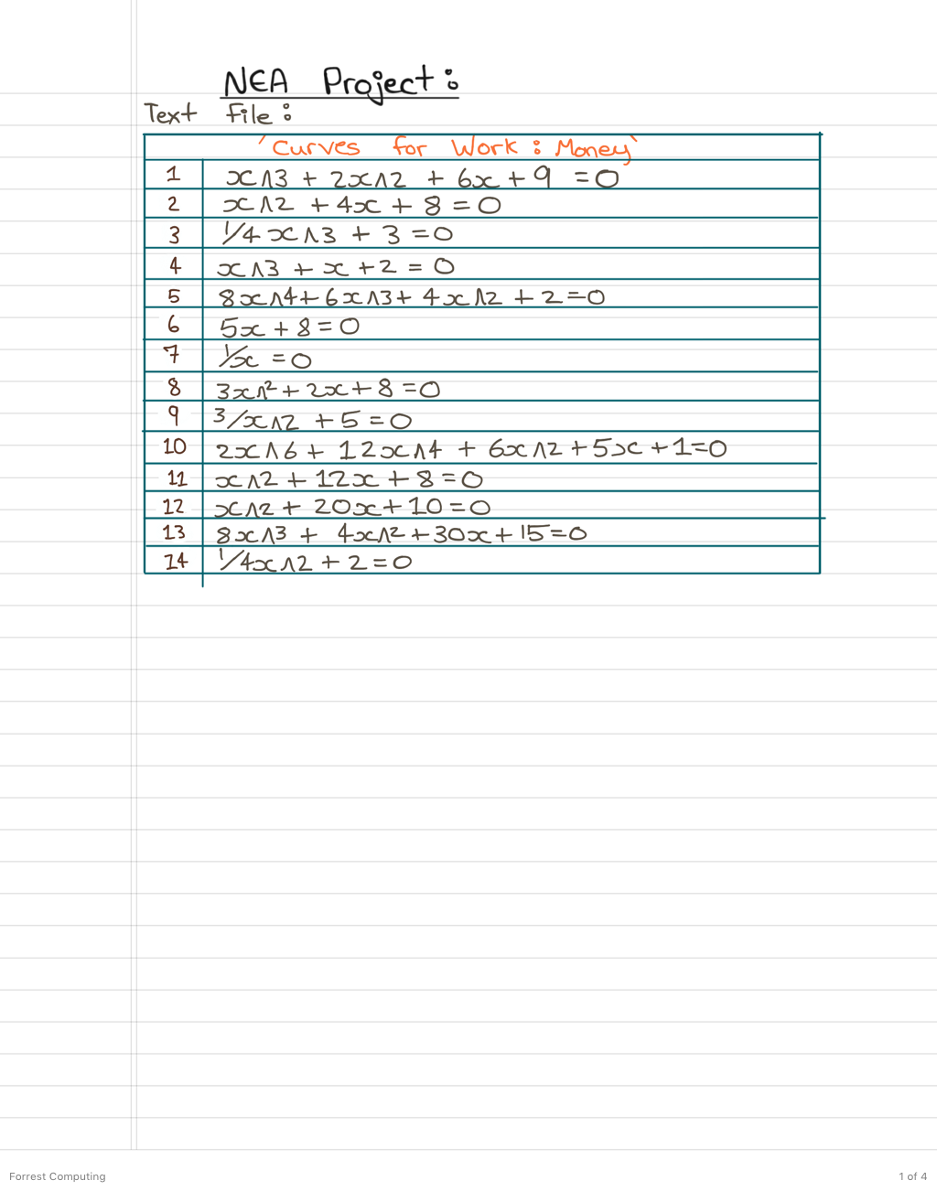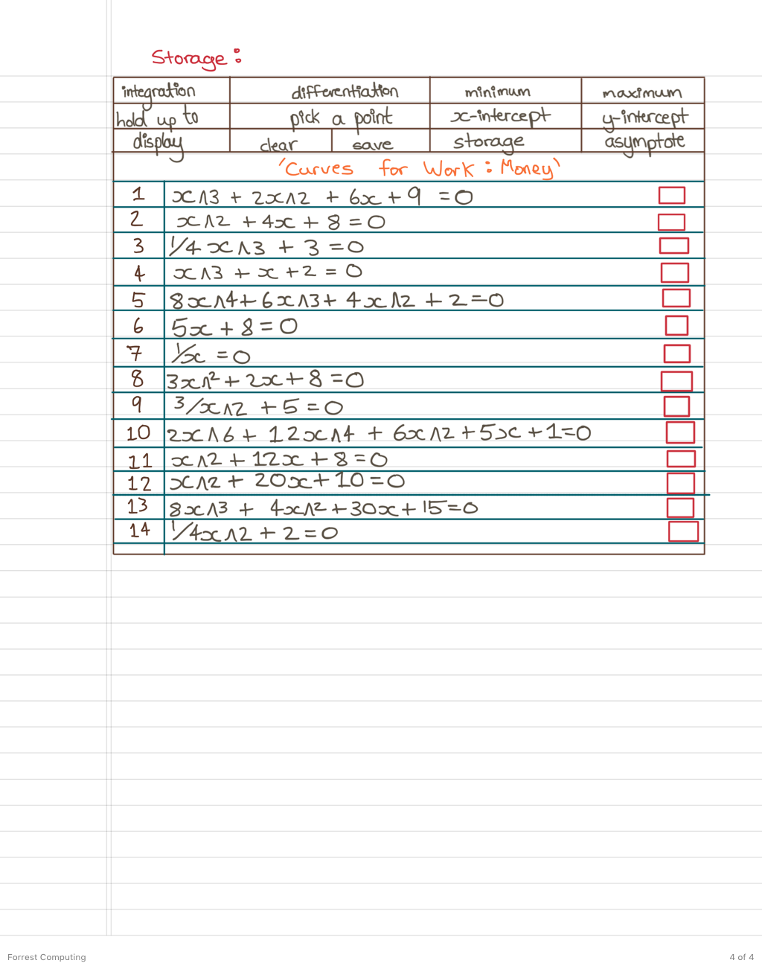

* 1. **Final SMART Objectives**

(Task: Go over the previous objectives and revise them, make it clearer and more concise, possibly add some more and get 20 clear objectives, minimum 10)

2. The user can write out the formula in a string and the calculator can take that string and use it to integrate, differentiate and create curves and graphs.

3. The ability to display graphs and save them in a text file, as well as being able to access and display them from the calculator again.

4. The ability to automatically display the curve’s maximum and minimum.

5. To automatically display where the line crosses the x and y axis automatically.

6. The ability to pick a point on the curve and for the co-ordinates to be displayed.

7. The ability to present up to 5 curves on a graph.

7. For the graph to automatically scale based on the formula written in the calculator.

9. For the calculator to store the previous answer until a new answer is created and stored in its place as well as being able to clear the screen.

10. For there to be no limit to the power of x to be entered and given.

1. The user can enter the equation (a polynomial) as a string and the program will translate and slice elements of that string, putting it together into a format that the computer understands.
2. On the interface/screen of the program you can have buttons that make it easier to navigate through the program, such as:
   1. Clearing the screen
   2. Home button, this allows you to go to the default screen which is the screen where the equation is entered
   3. Display Button, to display the equation that is written
   4. Storage button, that allows you to bring and use in the calculator
   5. Formula buttons to apply to the equation given (integration, differentiation, y intersection points etc.)
   6. The amount of graphs to hold and display
   7. Picking a point to show the co-ordinates of
   8. Saving a graph
3. To apply formulas on the equation that the computer understands such as:
   1. Integration
   2. Differentiation
   3. Area
   4. Displaying a point on the graph
   5. Figuring out the tangent
   6. Figuring out the normal
   7. Figuring out the minimum and maximum (or there might be a minimum turning point and a maximum turning point depending on the graph)
   8. Figuring out the asymptote
   9. Where graphs intersect
   10. Where the y-intersect is
   11. Where the x-intersect is
4. To clear the screen
5. To have a screen where you can save and upload polynomials and equations of a line so that the user can pull it up and use it again.
6. To be able hold up to 5 lines or curves